Here is the assignment I would like you to complete.
1) Find the most significant passage in chapter nine and write a paragraph following the model provided. The point is you are writing about something you see in the passage (for example: could be about characters, conflict, connections to other parts of the novel). Consider why you chose the passage in the first place. This could lead you to create a topic sentence. The topic sentence is a statement you are making based upon the passage you chose. You then support that statement with evidence from the passage (look on the second page for an example). If you need help or have questions send me an e-mail: TylerEvan.Secor@calbaptist.edu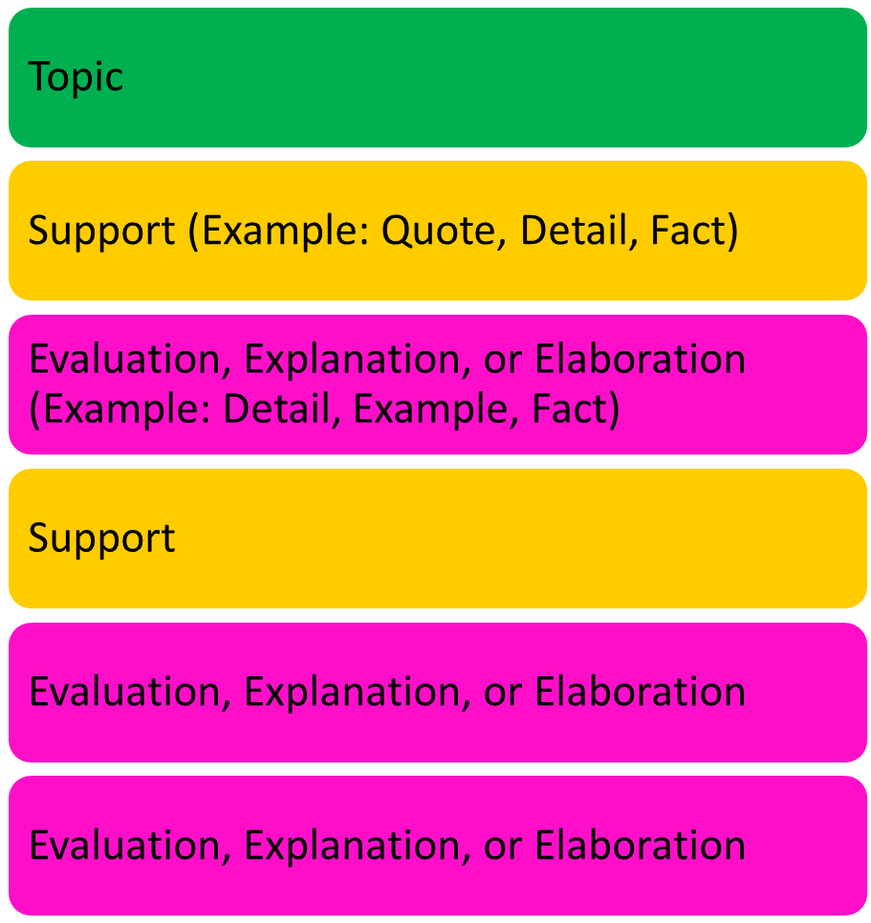

Example from Lord of the Flies:
Chapter Eight—Passage: page 139, paragraph 2-7
Some people either do not understand a remedy when they are presented with it or they do not care to consider it. Ralph said, “If a doctor said take this because if you don’t you’ll die—you would—wouldn’t you” (Golding 139)? Ralph is struggling with understanding why Jack and others who have deserted them would not want to keep the fire going so that they could be rescued (elaborate). Also, Ralph admits, “And they don’t care. And what’s more—I don’t sometimes. Supposing I got like the others—not caring” (Golding 139). Here, Ralph shows us that he sees the same carelessness in himself, and this worries him because he understands that this attitude could lead to their death (explain). Therefore, the passage highlights that stubbornness and selfishness are characteristics that are leading to group falling apart (evaluate).
Practice example done in class: Write about a fast food restaurant.
Chipotle consistently provides a good experience (topic sentence). When you order you have the option of selecting your own ingredients (fact). For example, a customer can choose what type of meat, beans, rice, sauce, and toppings (elaborate). Also, Chipotle offers antibiotic free chicken (fact). This shows the company uses animals that are raised naturally, so you are eating meat that has not been altered in any way (explain). Overall, Chipotle goes above and beyond expectations to provide good food (evaluate).
In the above paragraphs there are examples of the types of pink sentences you can use: elaboration, explanation, or evaluation.

